**Exercise – 3.2**

Write a **MATLAB m-code** to evaluate the per phase equivalent of a three phase transmission system fed with 66 kV, 50 Hz at the receiving end and supplying a load of 10 MW at 0.8 power factor (lag). The per-phase resistance and reactance of the line is 10 Ω and 20 Ω respectively, and per-phase shunt susceptance is $4×{10}^{-4}$ Siemen.

1. Compute the sending end voltage, sending end real and reactive power, power factor, line losses, efficiency and voltage regulation for the given load conditions.
2. Plot the sending end voltage, sending end real and reactive power, line losses, efficiency and voltage regulation if 66 kV is maintained at the receiving end, the load power (P) being varied from 0 to 20 MW in steps of 0.01 MW at a constant power factor of 0.8 (lag).

Hints:

1. Consider the **medium transmission line (nominal T-model)** representation
2. Line parameters are in 1-phase whereas the supply and load values are in 3-phase
3. Provide the results for 3-phase entities

**M-code:**

% Ex-3.2 (Transmission System)

% Sambhav R Jain

% 107108103

clc;

clear all;

close all;

fprintf('Ex-3.2 Medium Transmission Line (nominal T model)\n');

fprintf(' - Sambhav R Jain (107108103)\n\n');

V = input('Enter the receiving end line-line voltage (kV): ');

f = input('Enter the frequency (Hz): ');

P = input('Enter the 3-phase load power at the receiving end (MW): ');

pf = input('Enter the power factor of the load: ');

R = input('Enter the per-phase resistance of the line (ohm): ');

X = input('Enter the per-phase reactance of the line (ohm): ');

B = input('Enter the per-phase shunt susceptance of the line (mho or Siemen): ');

% Choosing receiving end as the phasor reference (0 deg)

Vr = 1e3*V; % receiving end line-line voltage in V

Pr = 1e6*P; % 3-phase load power in W

Z = R+X*1i;

Y = B*1i;

% Phase values:

vr = Vr/sqrt(3);

pr = Pr/3;

% Calculations

ir_mag = pr/(vr*pf);

ir_ang = -acos(pf);

ir = complex(ir_mag*cos(ir_ang),ir_mag*sin(ir_ang));

vc = vr+ir*Z/2;

ic = vc*Y;

is = ic+ir;

vs = vc+is*Z/2; % sending end phase voltage in V

vs_ll = sqrt(3)*abs(vs)/1e3; % sending end line-line voltage in kV

ps = abs(vs*is*cos(angle(vs)-angle(is))); % sending end 1-phase real power in W

ps3ph = 3*ps/1e6; % sending end 3-phase real power in MW

qs = abs(vs*is*sin(angle(vs)-angle(is))); % sending end 1-phase reactive power VAR

qs3ph = 3*qs/1e6; % sending end 3-phase reactive power in MVAR

pfs = cos(angle(vs)-angle(is)); % sending end power factor

loss = 3*(ps-pr)/1e6; % total 3-phase real power loss in MW

eff = pr/ps*100; % efficiency

VR = (abs(vs)-vr)/abs(vs)*100; % voltage regulation

fprintf('\nFor the given load conditions:\n');

disp('1. Sending end line-line voltage (kV): '); vs_ll

disp('2. Sending end 3-phase real power (MW): '); ps3ph

disp('3. Sending end 3-phase reactive power (MVAR): '); qs3ph

disp('4. Sending end power factor: '); pfs

disp('5. Total 3-phase real power loss in MW: '); loss

disp('6. % Efficiency: '); eff

disp('7. % Voltage Regulation: '); VR

n = 0;

for P = 0:.1:20

n = n+1;

a(n) = P;

pr = 1e6*P/3;

ir_mag = pr/(vr*pf);

ir_ang = -acos(pf);

ir = complex(ir_mag*cos(ir_ang),ir_mag*sin(ir_ang));

vc = vr+ir*Z/2;

ic = vc*Y;

is = ic+ir;

vs = vc+is*Z/2; % sending end phase voltage in V

vs_ll(n) = sqrt(3)*abs(vs); % sending end line-line voltage in V

ps = abs(vs*is*cos(angle(vs)-angle(is))); % sending end 1-phase real power in W

ps3ph(n) = 3*ps/1e6; % sending end 3-phase real power in MW

qs = abs(vs*is*sin(angle(vs)-angle(is))); % sending end 1-phase reactive power VAR

qs3ph(n) = 3*qs/1e6; % sending end 3-phase reactive power in MVAR

pfs = cos(angle(vs)-angle(is)); % sending end power factor

loss(n) = 3*(ps-pr)/1e6; % total 3-phase real power loss in MW

eff(n) = pr/ps*100; % efficiency

VR(n) = (abs(vs)-vr)/abs(vs)*100; % voltage regulation

end

subplot(3,2,1);

plot(a,vs_ll); grid on; xlabel('Load Power (MW) ---->'); ylabel('Vs (V) ---->'); title('Sending end line-line voltage v/s load');

subplot(3,2,2);

plot(a,ps3ph); grid on; xlabel('Load Power (MW) ---->'); ylabel('Ps (MW) ---->'); title('Sending end 3-phase real power v/s load');

subplot(3,2,3);

plot(a,qs3ph); grid on; xlabel('Load Power (MW) ---->'); ylabel('Qs (MVAR) ---->'); title('Sending end 3-phase reactive power v/s load');

subplot(3,2,4);

plot(a,loss); grid on; xlabel('Load Power (MW) ---->'); ylabel('Loss (MW) ---->'); title('Total 3-phase real power loss v/s load');

subplot(3,2,5);

plot(a,eff); grid on; xlabel('Load Power (MW) ---->'); ylabel('% Efficiency --->'); title('Efficiency v/s load');

subplot(3,2,6);

plot(a,VR); grid on; xlabel('Load Power (MW) ---->'); ylabel('% VR ---->'); title('Voltage regulation v/s load');

**Terminal Display:**

Ex-3.2 Medium Transmission Line (nominal T model)

- Sambhav R Jain (107108103)

Enter the receiving end line-line voltage (kV): 66

Enter the frequency (Hz): 50

Enter the 3-phase load power at the receiving end (MW): 10

Enter the power factor of the load: 0.8

Enter the per-phase resistance of the line (ohm): 10

Enter the per-phase reactance of the line (ohm): 20

Enter the per-phase shunt susceptance of the line (mho or Siemen): 4e-4

For the given load conditions:

1. Sending end line-line voltage (kV):

vs_ll =

69.5439

2. Sending end 3-phase real power (MW):

ps3ph =

10.3310

3. Sending end 3-phase reactive power (MVAR):

qs3ph =

6.3177

4. Sending end power factor:

pfs =

0.8531

5. Total 3-phase real power loss in MW:

loss =

0.3310

6. % Efficiency:

eff =

96.7965

7. % Voltage Regulation:

VR =

5.0960

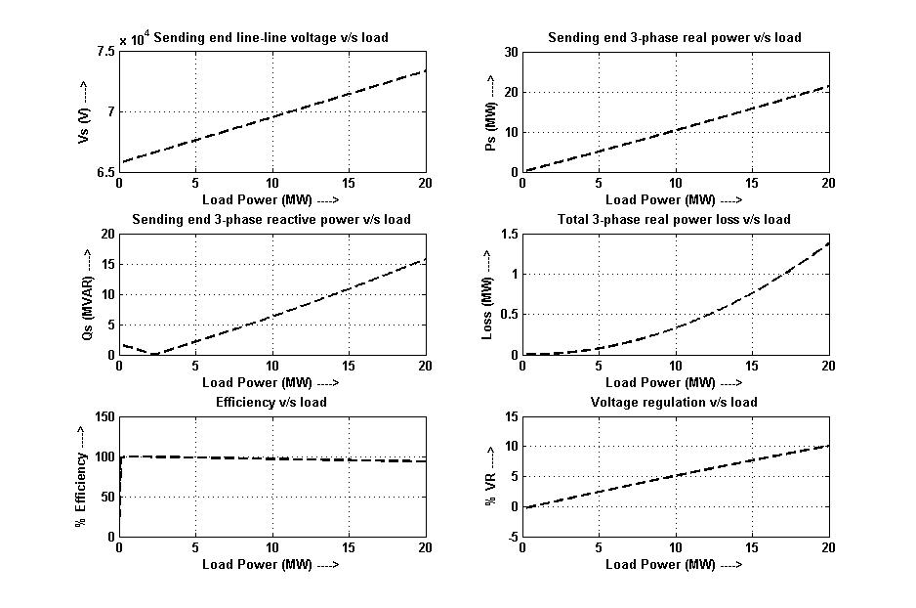**Waveforms:**

**Results:**

Hence the per phase equivalent representation of a medium transmission line using nominal T-model is employed to compute the required data and the required plots.